DAY - 1 HACKERRANK PROBLEMS SOLVED

1.Repeated String

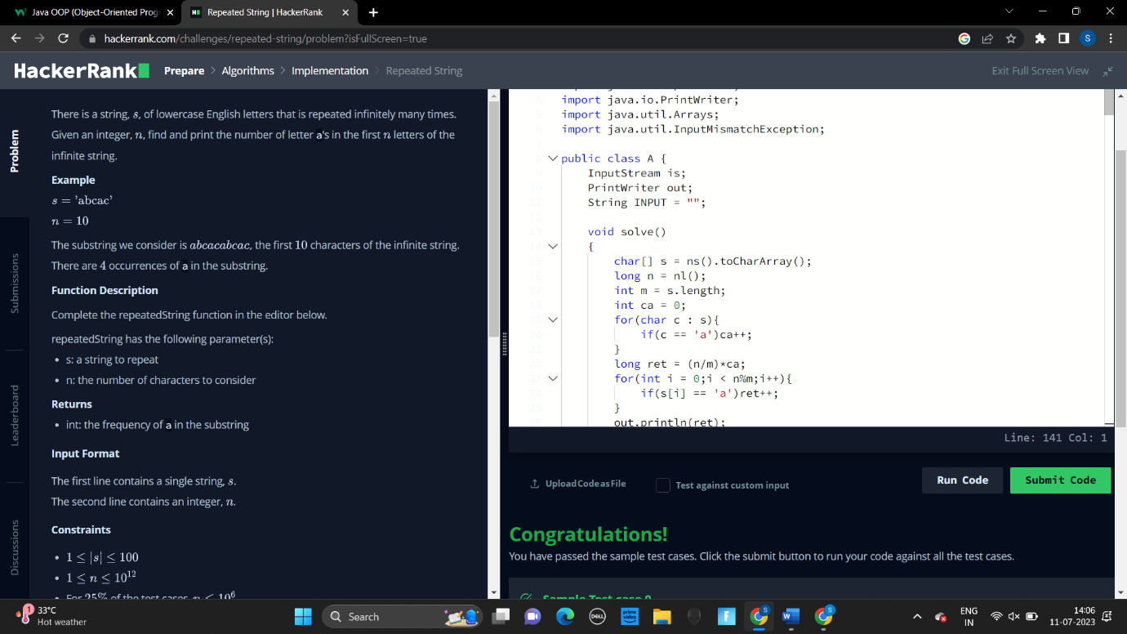

2.Simple Array Sum

